Experiment-22
AIM:- To show data set and perform the Apriori Algorithm and FP algorithm s Procedure
1.Open the notepad and select the new page.
2.enter the ARFF code for following question .
3. save the file as example -exp24.arff.
4. open the weka compiler.
5.select the explore option.
6. open the file .
7. select the associate option .
8. select apriori edit the min support and min mertic.
9. clik the start it displays output for apriori algorithm.
10.select FP-growth edit the min support
11. clik the start it displays output for FP-growth.
Code:-
@relation market_transactions
@attribute a {0,1}
@attribute b {0,1}
@attribute c {0,1}
@attribute d {0,1}
@attribute e {0,1}
@data
1,0,0,1,1 % 0001 → {a,d,e}
1,1,1,0,1 % 0024 → {a,b,c,e}
1,1,0,1,1 % 0012 → {a,b,d,e}
1,0,1,1,1 % 0031 → {a,c,d,e}
0,1,1,0,1 % 0015 → {b,c,e}
0,1,0,1,1 % 0022 → {b,d,e}
0,0,1,1,0 % 0029 → {c,d}
1,1,1,0,0 % 0040 → {a,b,c}
1,0,0,1,1 % 0033 → {a,d,e}
1,1,0,0,1 % 0038 → {a,b,e}
Output:-
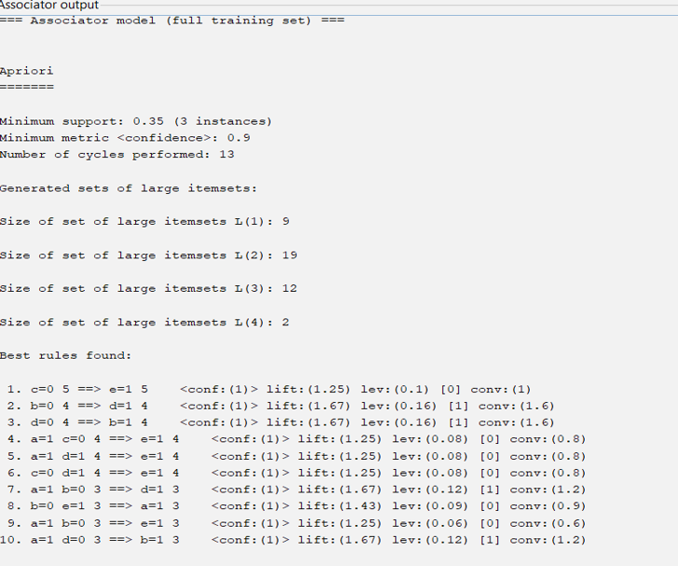
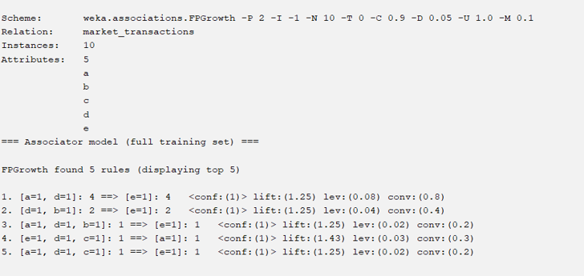
Result:- It is executed successfully.
Experiment-23
Aim:- :- To show data set and perform the Apriori Algorithm and FP algorithm s Procedure
1.Open the notepad and select the new page.
2.enter the ARFF code for following question .
3. save the file as example -exp24.arff.
4. open the weka compiler.
5.select the explore option.
6. open the file .
7. select the associate option .
8. select apriori edit the min support and min mertic.
9. clik the start it displays output for apriori algorithm.
10.select FP-growth edit the min support
11. clik the start it displays output for FP-growth.
Code:-
@relation market_basket
@attribute Milk {yes,no}
@attribute Bread {yes,no}
@attribute Butter {yes,no}
@attribute Eggs {yes,no}
@attribute Cheese {yes,no}
@data
yes,yes,no,yes,no
no,yes,yes,no,yes
yes,no,yes,yes,no
yes,yes,yes,no,yes
no,no,yes,yes,no
output:-
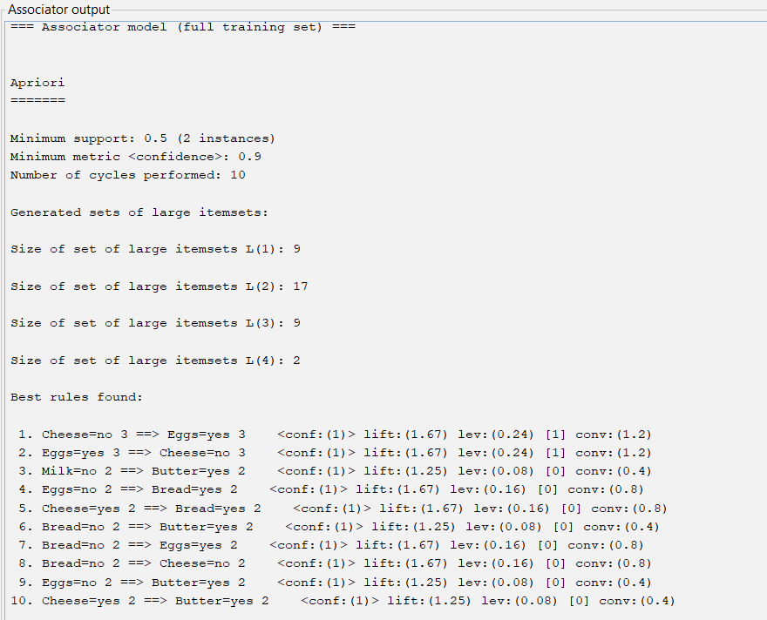

Result:- It is executed successfully.
Experiment-24
Aim:- To show Bayes classification and descion tree.
Procedure
1.Open the notepad and select the new page.
2.enter the ARFF code for following question .
3. save the file as example -exp24.arff.
4. open the weka compiler.
5.select the explore option.
6. open the file .
7. select the classify option .
8. select Navi bayes.
9. clik the start it displays output for Navi bayes algorithm.
10.select J48
11. clik the start it displays output for J48.
Output:-
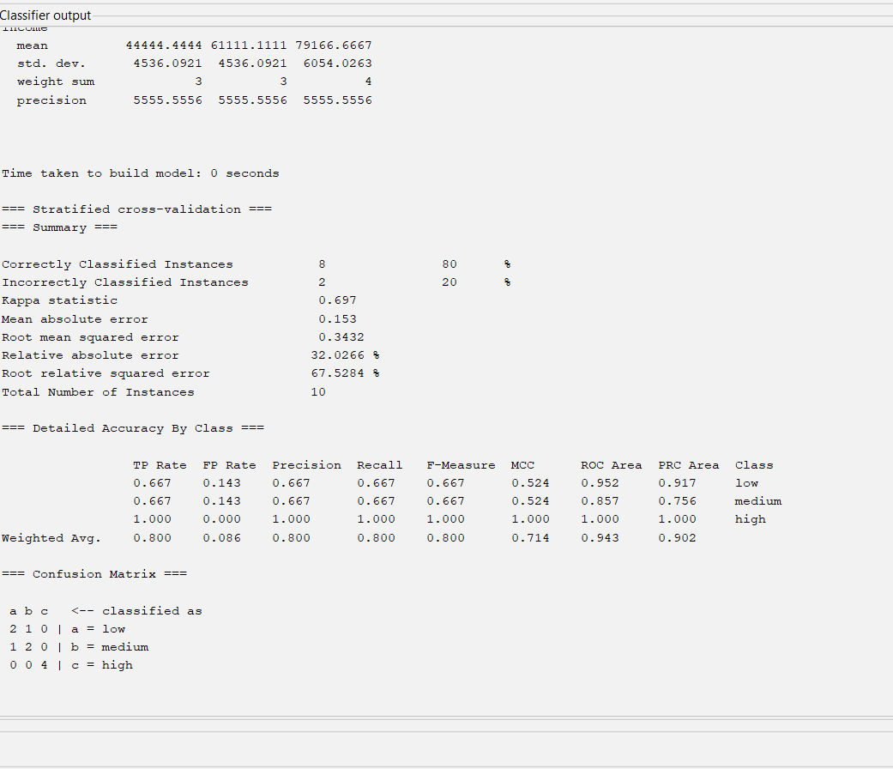
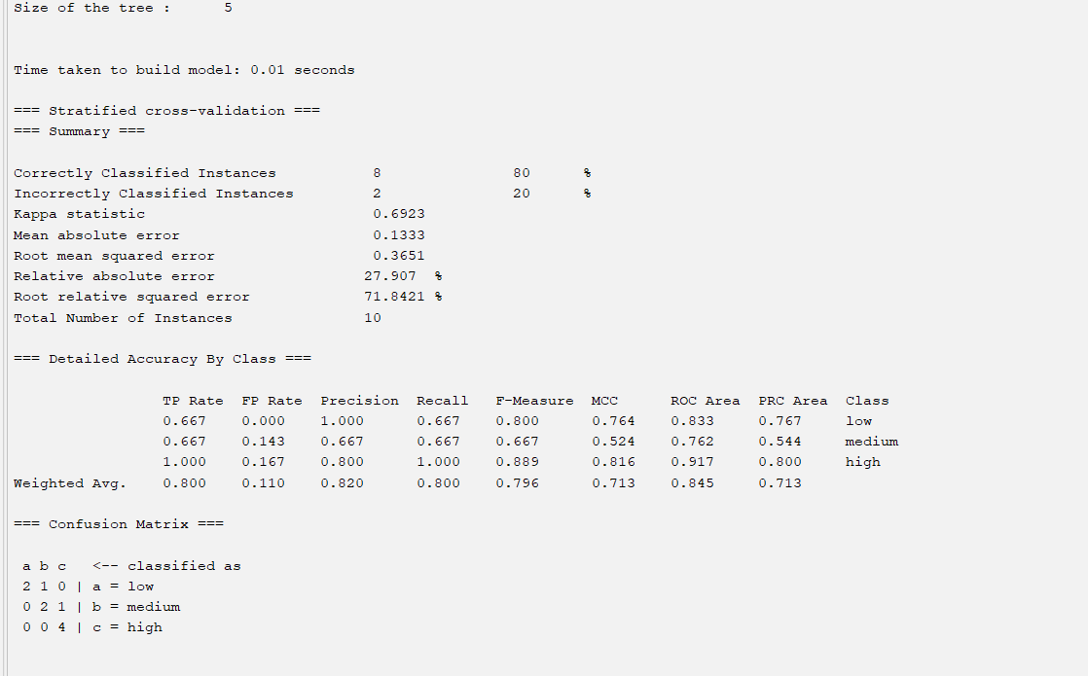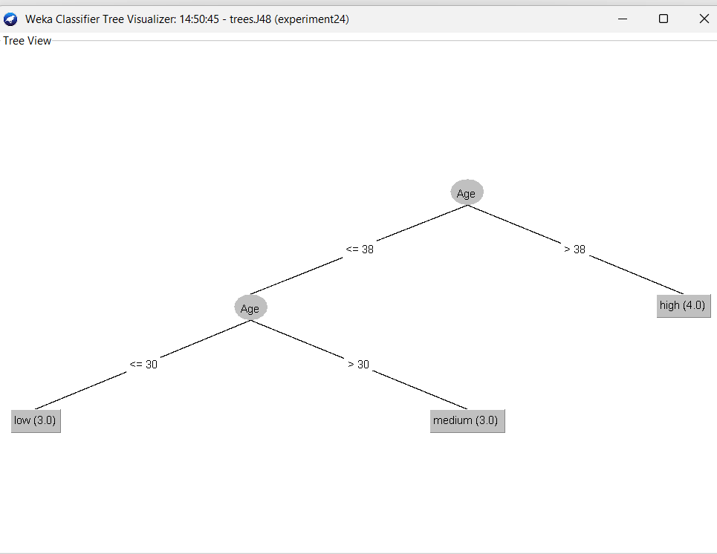Result:- It is executed successfully.

